Weston Canonical Correlation Figures

# Canonical Correlation Analysis

## 5CSRTT

### 3xTG

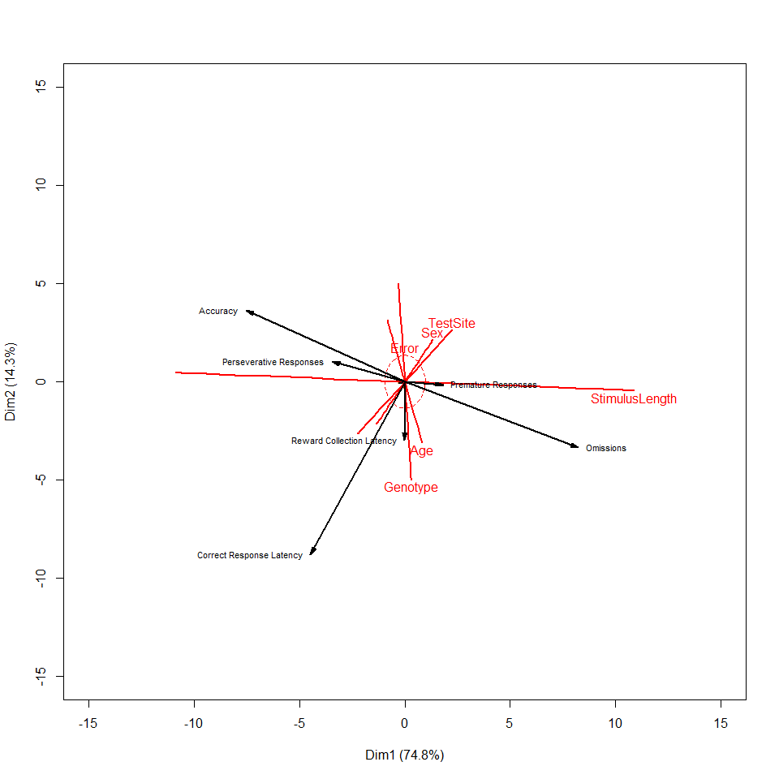

##   
## Canonical correlation analysis of:  
## 5 Mouse Factors variables: TestSite, Genotype, Sex, Age, StimulusLength   
## with 6 Behavioural Measures variables: Accuracy, Omissions, Premature Responses, Perseverative Responses, Reward Collection Latency, Correct Response Latency   
##   
## CanR CanRSQ Eigen percent cum scree  
## 1 0.7912 0.62604 1.67406 74.8443 74.84 ******************************  
## 2 0.4918 0.24183 0.31896 14.2601 89.10 ******   
## 3 0.3402 0.11575 0.13090 5.8522 94.96 **   
## 4 0.2895 0.08384 0.09151 4.0912 99.05 **   
## 5 0.1444 0.02085 0.02130 0.9522 100.00   
##   
## Test of H0: The canonical correlations in the   
## current row and all that follow are zero  
##   
## CanR LR test stat approx F numDF denDF Pr(> F)   
## 1 0.79122 0.22490 58.202 30 3862.0 < 2.2e-16 ***  
## 2 0.49176 0.60140 26.551 20 3204.8 < 2.2e-16 ***  
## 3 0.34022 0.79323 19.511 12 2558.7 < 2.2e-16 ***  
## 4 0.28955 0.89706 18.011 6 1936.0 < 2.2e-16 ***  
## 5 0.14441 0.97915 2   
## ---  
## Signif. codes: 0 '***' 0.001 '**' 0.01 '*' 0.05 '.' 0.1 ' ' 1

### 5xFAD

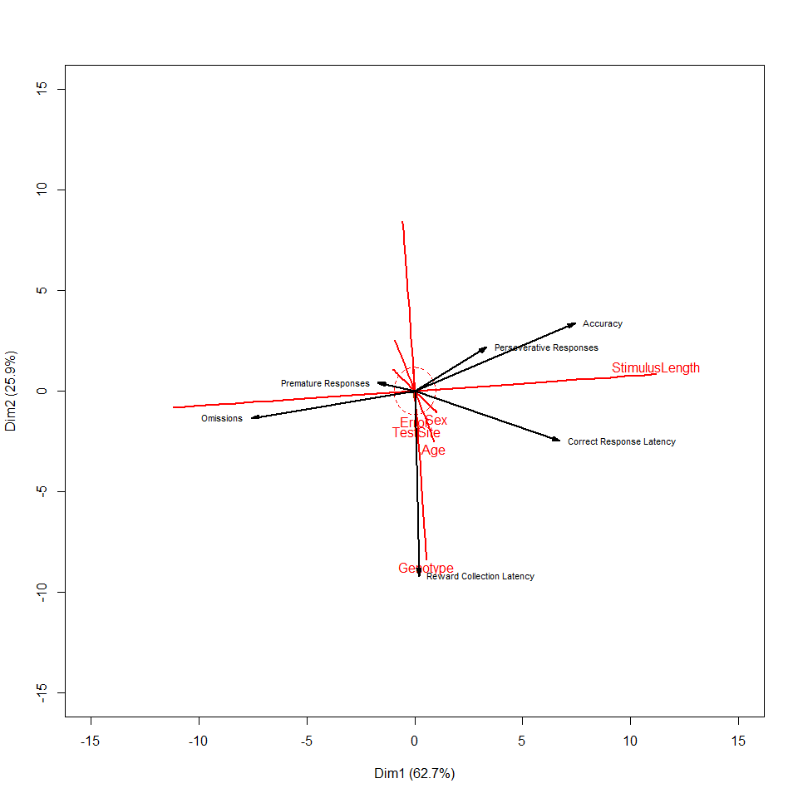

##   
## Canonical correlation analysis of:  
## 5 Mouse Factors variables: TestSite, Genotype, Sex, Age, StimulusLength   
## with 6 Behavioural Measures variables: Accuracy, Omissions, Premature Responses, Perseverative Responses, Reward Collection Latency, Correct Response Latency   
##   
## CanR CanRSQ Eigen percent cum scree  
## 1 0.7912 0.62599 1.67373 62.738 62.74 ******************************  
## 2 0.6391 0.40839 0.69031 25.876 88.61 ************   
## 3 0.3929 0.15438 0.18256 6.843 95.46 ***   
## 4 0.2503 0.06267 0.06686 2.506 97.96 *   
## 5 0.2271 0.05155 0.05435 2.037 100.00 *   
##   
## Test of H0: The canonical correlations in the   
## current row and all that follow are zero  
##   
## CanR LR test stat approx F numDF denDF Pr(> F)   
## 1 0.79120 0.16634 73.448 30 3894.0 < 2.2e-16 ***  
## 2 0.63906 0.44475 44.710 20 3231.3 < 2.2e-16 ***  
## 3 0.39291 0.75177 24.482 12 2579.9 < 2.2e-16 ***  
## 4 0.25034 0.88901 19.711 6 1952.0 < 2.2e-16 ***  
## 5 0.22705 0.94845 2   
## ---  
## Signif. codes: 0 '***' 0.001 '**' 0.01 '*' 0.05 '.' 0.1 ' ' 1

### APP/PS1

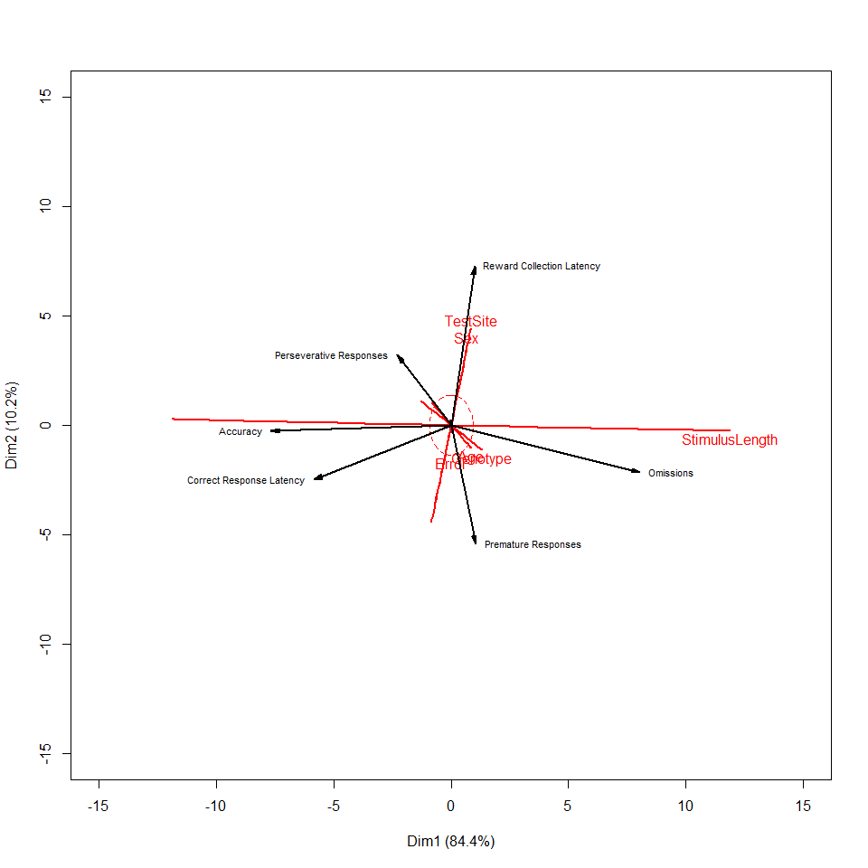

##   
## Canonical correlation analysis of:  
## 5 Mouse Factors variables: TestSite, Genotype, Sex, Age, StimulusLength   
## with 6 Behavioural Measures variables: Accuracy, Omissions, Premature Responses, Perseverative Responses, Reward Collection Latency, Correct Response Latency   
##   
## CanR CanRSQ Eigen percent cum scree  
## 1 0.79477 0.631657 1.71486 84.4296 84.43 ******************************  
## 2 0.41481 0.172071 0.20783 10.2325 94.66 ****   
## 3 0.26081 0.068020 0.07298 3.5933 98.26 *   
## 4 0.16021 0.025668 0.02634 1.2970 99.55   
## 5 0.09491 0.009008 0.00909 0.4475 100.00   
##   
## Test of H0: The canonical correlations in the   
## current row and all that follow are zero  
##   
## CanR LR test stat approx F numDF denDF Pr(> F)   
## 1 0.79477 0.27443 56.660 30 4454.0 < 2.2e-16 ***  
## 2 0.41481 0.74504 17.148 20 3695.7 < 2.2e-16 ***  
## 3 0.26081 0.89988 10.001 12 2950.3 < 2.2e-16 ***  
## 4 0.16021 0.96556 6.577 6 2232.0 6.681e-07 ***  
## 5 0.09491 0.99099 2   
## ---  
## Signif. codes: 0 '***' 0.001 '**' 0.01 '*' 0.05 '.' 0.1 ' ' 1

## PD

### 3xTG

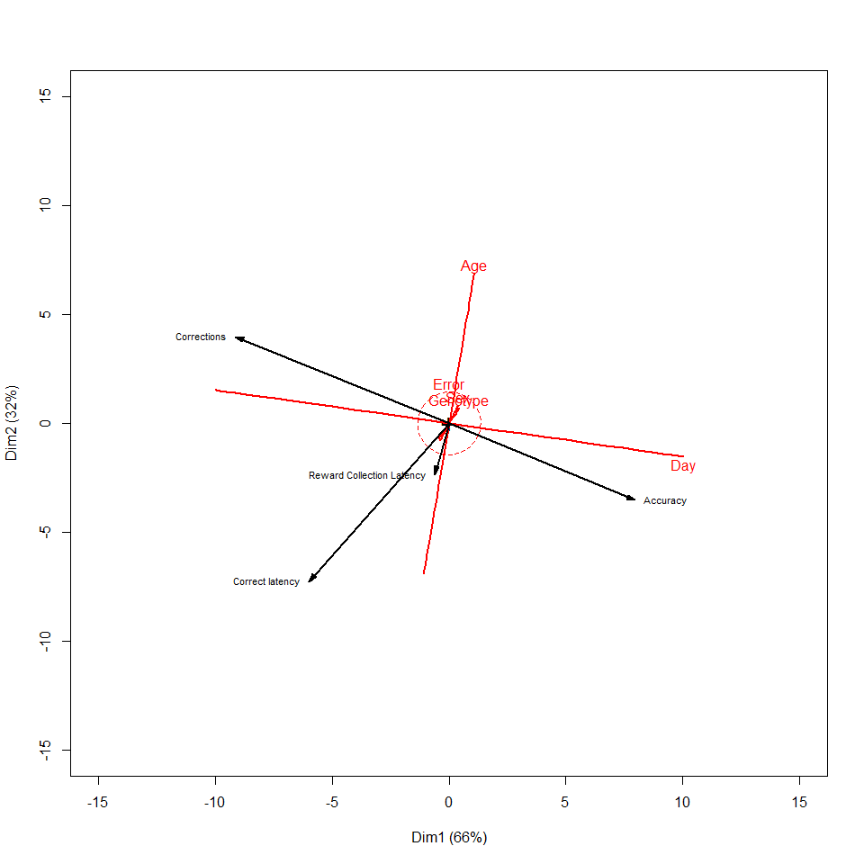

##   
## Canonical correlation analysis of:  
## 4 Mouse Factors variables: Genotype, Sex, Age, Day   
## with 4 Behavioural Measures variables: Accuracy, Corrections, Correct latency, Reward Collection Latency   
##   
## CanR CanRSQ Eigen percent cum scree  
## 1 0.45982 0.211433 0.268122 65.9966 66.00 ******************************  
## 2 0.33902 0.114933 0.129858 31.9638 97.96 ***************   
## 3 0.08321 0.006924 0.006972 1.7162 99.68 *   
## 4 0.03622 0.001312 0.001314 0.3234 100.00   
##   
## Test of H0: The canonical correlations in the   
## current row and all that follow are zero  
##   
## CanR LR test stat approx F numDF denDF Pr(> F)   
## 1 0.45982 0.69219 50.097 16 6263.5 < 2.2e-16 ***  
## 2 0.33902 0.87779 30.517 9 4991.7 < 2.2e-16 ***  
## 3 0.08321 0.99177 4.247 4 4104.0 0.001971 **   
## 4 0.03622 0.99869 2.697 1 2053.0 0.100663   
## ---  
## Signif. codes: 0 '***' 0.001 '**' 0.01 '*' 0.05 '.' 0.1 ' ' 1

### 5xFAD

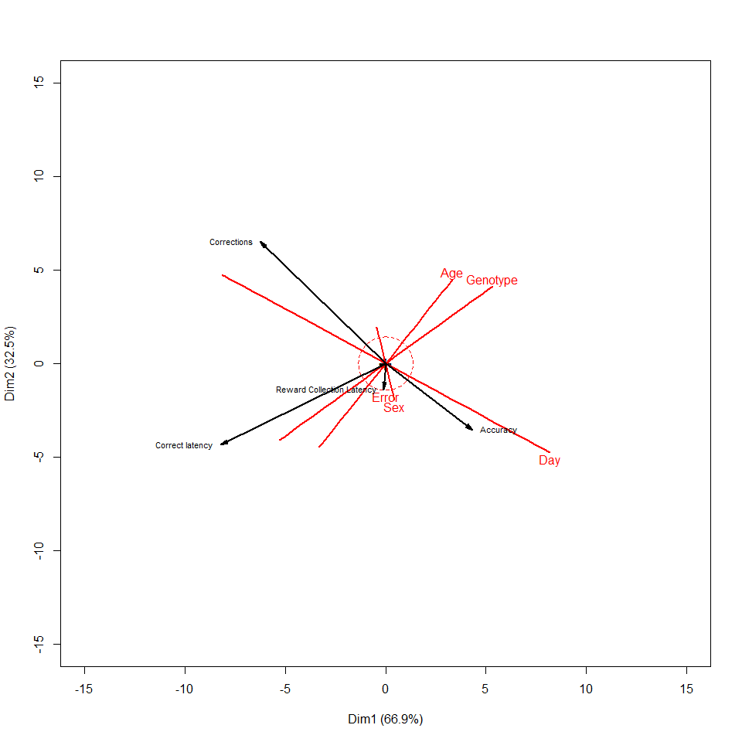

##   
## Canonical correlation analysis of:  
## 4 Mouse Factors variables: Genotype, Sex, Age, Day   
## with 4 Behavioural Measures variables: Accuracy, Corrections, Correct latency, Reward Collection Latency   
##   
## CanR CanRSQ Eigen percent cum  
## 1 0.45096 0.2033620 0.2552753 66.8860 66.89  
## 2 0.33233 0.1104440 0.1241563 32.5308 99.42  
## 3 0.04095 0.0016769 0.0016797 0.4401 99.86  
## 4 0.02336 0.0005458 0.0005461 0.1431 100.00  
## scree  
## 1 ******************************  
## 2 ***************   
## 3   
## 4   
##   
## Test of H0: The canonical correlations in the   
## current row and all that follow are zero  
##   
## CanR LR test stat approx F numDF denDF Pr(> F)   
## 1 0.45096 0.70708 54.166 16 7213.6 <2e-16 ***  
## 2 0.33233 0.88758 32.079 9 5748.6 <2e-16 ***  
## 3 0.04095 0.99778 1.315 4 4726.0 0.2619   
## 4 0.02336 0.99945 1.291 1 2364.0 0.2560   
## ---  
## Signif. codes: 0 '***' 0.001 '**' 0.01 '*' 0.05 '.' 0.1 ' ' 1

### APP/PS1

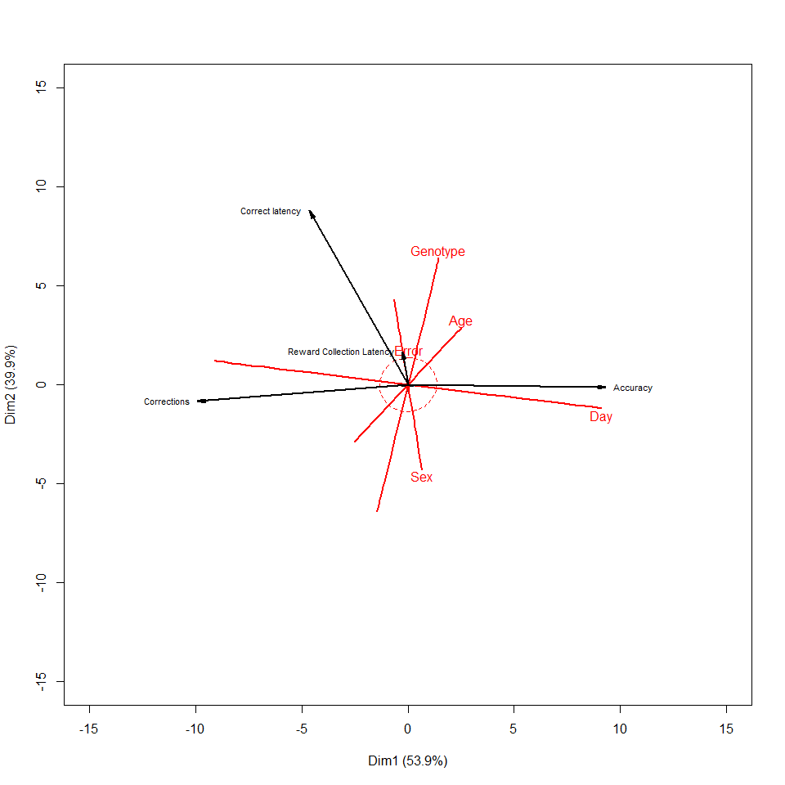

##   
## Canonical correlation analysis of:  
## 4 Mouse Factors variables: Genotype, Sex, Age, Day   
## with 4 Behavioural Measures variables: Accuracy, Corrections, Correct latency, Reward Collection Latency   
##   
## CanR CanRSQ Eigen percent cum scree  
## 1 0.4740 0.224660 0.289757 53.9250 53.93 ******************************  
## 2 0.4203 0.176683 0.214599 39.9377 93.86 **********************   
## 3 0.1743 0.030391 0.031343 5.8331 99.70 ***   
## 4 0.0404 0.001632 0.001634 0.3042 100.00   
##   
## Test of H0: The canonical correlations in the   
## current row and all that follow are zero  
##   
## CanR LR test stat approx F numDF denDF Pr(> F)   
## 1 0.47398 0.61794 57.454 16 5386.7 < 2.2e-16 ***  
## 2 0.42034 0.79699 46.615 9 4293.3 < 2.2e-16 ***  
## 3 0.17433 0.96803 14.456 4 3530.0 1.035e-11 ***  
## 4 0.04040 0.99837 2.886 1 1766.0 0.0895 .   
## ---  
## Signif. codes: 0 '***' 0.001 '**' 0.01 '*' 0.05 '.' 0.1 ' ' 1

## PAL

### 3xTG

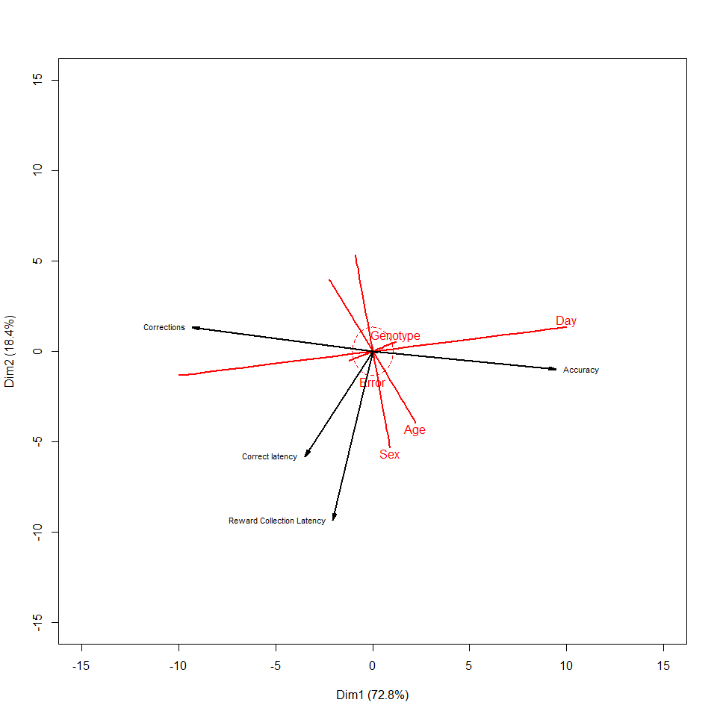

##   
## Canonical correlation analysis of:  
## 4 Mouse Factors variables: Genotype, Sex, Age, Day   
## with 4 Behavioural Measures variables: Accuracy, Corrections, Correct latency, Reward Collection Latency   
##   
## CanR CanRSQ Eigen percent cum scree  
## 1 0.7197 0.51796 1.07451 72.837 72.84 ******************************  
## 2 0.4619 0.21336 0.27123 18.386 91.22 ********   
## 3 0.2951 0.08706 0.09536 6.464 97.69 ***   
## 4 0.1816 0.03299 0.03412 2.313 100.00 *   
##   
## Test of H0: The canonical correlations in the   
## current row and all that follow are zero  
##   
## CanR LR test stat approx F numDF denDF Pr(> F)   
## 1 0.71969 0.33476 71.163 16 2643.3 < 2.2e-16 ***  
## 2 0.46191 0.69446 37.851 9 2107.8 < 2.2e-16 ***  
## 3 0.29506 0.88282 27.873 4 1734.0 < 2.2e-16 ***  
## 4 0.18164 0.96701 29.614 1 868.0 6.861e-08 ***  
## ---  
## Signif. codes: 0 '***' 0.001 '**' 0.01 '*' 0.05 '.' 0.1 ' ' 1

### 5xFAD

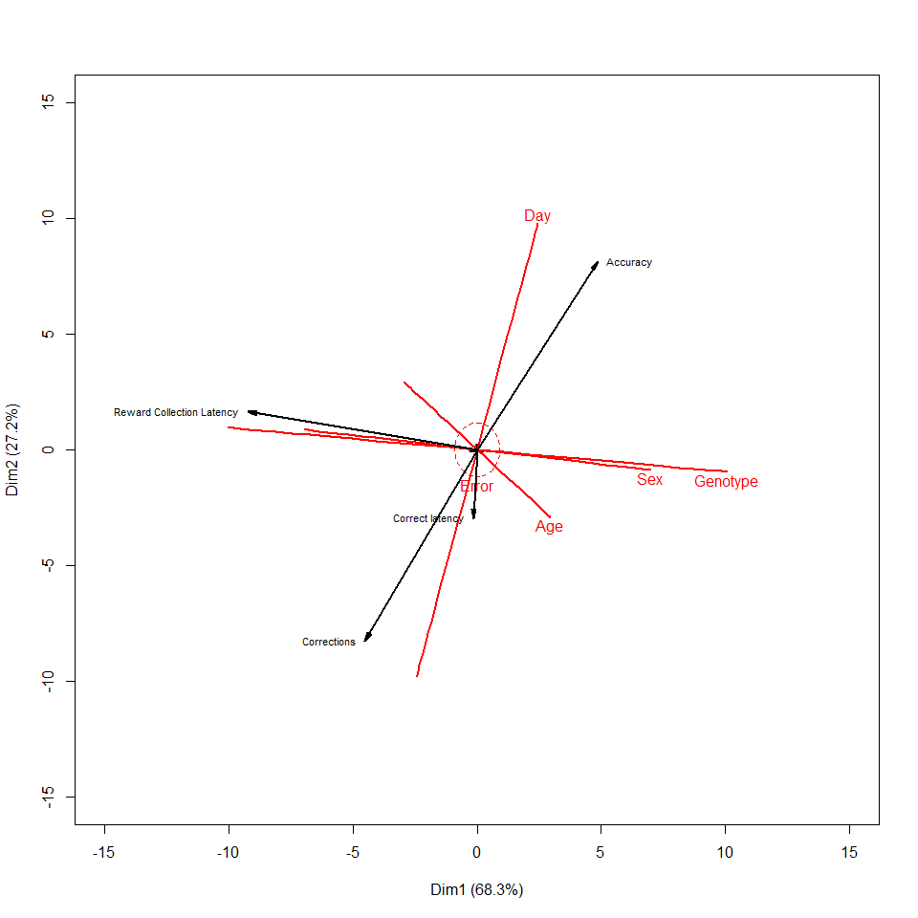

##   
## Canonical correlation analysis of:  
## 4 Mouse Factors variables: Genotype, Sex, Age, Day   
## with 4 Behavioural Measures variables: Accuracy, Corrections, Correct latency, Reward Collection Latency   
##   
## CanR CanRSQ Eigen percent cum scree  
## 1 0.79675 0.63481 1.738307 68.2805 68.28 ******************************  
## 2 0.63976 0.40929 0.692873 27.2160 95.50 ************   
## 3 0.31551 0.09955 0.110554 4.3426 99.84 **   
## 4 0.06388 0.00408 0.004097 0.1609 100.00   
##   
## Test of H0: The canonical correlations in the   
## current row and all that follow are zero  
##   
## CanR LR test stat approx F numDF denDF Pr(> F)   
## 1 0.79675 0.19345 147.005 16 3303.1 < 2e-16 ***  
## 2 0.63976 0.52974 87.290 9 2633.5 < 2e-16 ***  
## 3 0.31551 0.89678 30.316 4 2166.0 < 2e-16 ***  
## 4 0.06388 0.99592 4.441 1 1084.0 0.03531 *   
## ---  
## Signif. codes: 0 '***' 0.001 '**' 0.01 '*' 0.05 '.' 0.1 ' ' 1

### APP/PS1

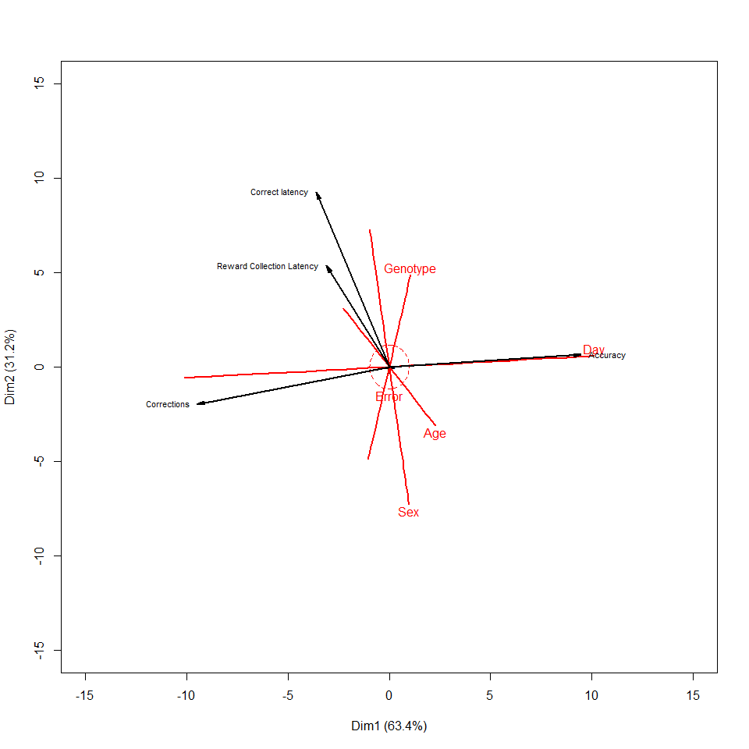

##   
## Canonical correlation analysis of:  
## 4 Mouse Factors variables: Genotype, Sex, Age, Day   
## with 4 Behavioural Measures variables: Accuracy, Corrections, Correct latency, Reward Collection Latency   
##   
## CanR CanRSQ Eigen percent cum  
## 1 0.7669108 5.882e-01 1.428e+00 6.342e+01 63.42  
## 2 0.6425631 4.129e-01 7.033e-01 3.123e+01 94.66  
## 3 0.3277418 1.074e-01 1.203e-01 5.345e+00 100.00  
## 4 0.0003059 9.357e-08 9.357e-08 4.155e-06 100.00  
## scree  
## 1 ******************************  
## 2 ***************   
## 3 ***   
## 4   
##   
## Test of H0: The canonical correlations in the   
## current row and all that follow are zero  
##   
## CanR LR test stat approx F numDF denDF Pr(> F)   
## 1 0.76691 0.21583 95.487 16 2343.9 <2e-16 ***  
## 2 0.64256 0.52405 63.158 9 1869.3 <2e-16 ***  
## 3 0.32774 0.89259 22.479 4 1538.0 <2e-16 ***  
## 4 0.00031 1.00000 0.000 1 770.0 0.9932   
## ---  
## Signif. codes: 0 '***' 0.001 '**' 0.01 '*' 0.05 '.' 0.1 ' ' 1